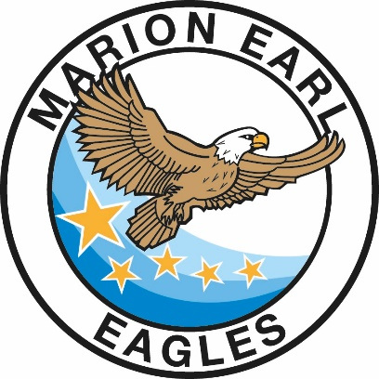
MARION EARL ELEMENTARY SCHOOL

6650 W. RENO AVENUE
LAS VEGAS, NEVADA 89118
Phone: (702) 799-8181 ● Fax: (702) 799-8188
Veronica A. Hunt, Principal
Aimee Levy, Assistant Principal
marionearl.com

Title I
Parents’ Right-to-Know

The Every Student Succeeds Act (ESSA) was passed by the U.S. Congress and signed into law on December 10, 2015. The ESSA replaces the No Child Left Behind Act (NCLB) and is the latest reauthorization of the Elementary and Secondary Education Act (ESEA).

Although NCLB was designed to make changes in teaching and learning in order to increase students’ academic achievement, the Highly Qualified Teacher (HQT) provision under NCLB was eliminated from the ESSA. Despite this fact, all educators in Nevada still are required to hold the appropriate state certificate/license for their given position.

Under ESSA, all schools receiving Title I funds must inform parents of their right to ask schools about the professional qualifications of their child’s teachers. If you would like to view a teacher’s license, please access this link: https://online.nvdoe.org/#/VerifyLicense.

Parents are encouraged to support their child’s education and communicate with their child’s teacher(s) on a regular basis. For more information on ESSA and the role of parents, please visit the United States Department of Education’s website at https://www2.ed.gov/policy/elsec/leg/essa/index.html.

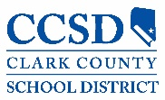

Our mission is to provide the tools for students to be independent and successful, both academically and socially.

5100 West Sahara Avenue
Las Vegas, Nevada 89146

