First Grade Supply List
Suggested Supplies

The Clark County School District will provide all necessary supplies to students. These items are not mandatory. Any item you are able to donate would be appreciated.
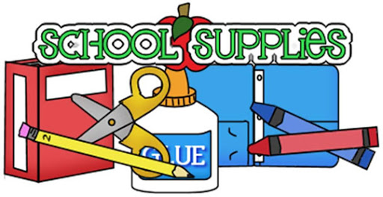

- Hand Sanitizer & Disinfecting Wipes
- 1 box (16 count) crayons
- 2 boxes of yellow #2 pencils
- 15 glue sticks
- 5 pink erasers
- 1 pair of FISKARS® for kids No. 5 blunt-tip scissors
- 1 plastic crayon/pencil box, 8 ½” x 5 ½”
- 1 box of low sugar snacks (animal crackers, cheez-its, pretzels, graham crackers, goldfish, ritz crackers, wheat thins, etc.)
- 1 anti-bacterial liquid hand soap
- 3 reams of white copy paper
- 1 packet of colored printer paper
- 1 box of Ziploc gallon bags
- 1 box of sandwich bags
- 2 boxes of facial tissue
- 1 packet of white board markers

