Third Grade Supply List
Suggested Supplies

The Clark County School District will provide all necessary supplies to students. These items are not mandatory. Any item you are able to donate would be appreciated.
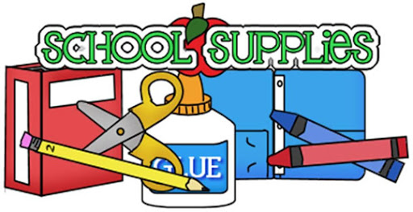

- Hand Sanitizer & Disinfecting Wipes
- 2 packages of yellow #2 pencils (NO mechanical pencils)
- 2 reams of white copy paper
- 2 pens
- 1 highlighter
- 1 package of glue sticks
- 1 package colored pencils or crayons (no larger than 48 count)
- 1 pair of scissors
- 2 large boxes of facial tissues
- 2 pocket folders
- 2 composition notebooks (no spiral notebooks)
- 1 package of dry erase markers
- 1 package pink erasers
- 1 pencil box
- 1 package of notebook paper lined (wide rule)
- 1 box of Gallon sized bags
- 1 box of sandwich sized bags

