MARION EARL ELEMENTARY SCHOOL

6650 W. RENO AVENUE
LAS VEGAS, NEVADA 89118
Phone: (702) 799-8181 ● Fax: (702) 799-8188
Veronica A. Hunt, Principal
Aimee Levy, Assistant Principal
marionearl.com

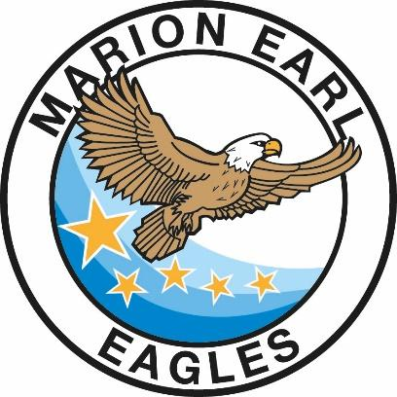
March 15, 2022
Dear Parents/Guardians:
Marion Earl is excited to announce that we will be hosting the Summer Acceleration Program again this year! While Summer Acceleration is not required, it serves as a fantastic opportunity for your child(ren) to receive further instruction to prepare for the following school year, while building on their social/emotional development. Below are the details surrounding Summer Acceleration:
- Summer Acceleration begins Tuesday May 31st, and ends on Friday, June 17th.
- There will be no Summer Acceleration on Tuesday, June 14th.
- Summer Acceleration will take place Monday-Friday during the regularly scheduled school day (8:35a.m.-3:11p.m.).
- Summer Acceleration will only take place following the face-to-face instruction model (no distance learning options are available).
- Transportation will be provided for students who are eligible.
- Food service will be provided.
- There will be no SafeKey offered during Summer Acceleration.
If you have not done so already, please click on the link below to complete the Summer Acceleration Parent Survey. A paper copy of the survey will be provided to you as well. You may complete EITHER the paper copy, or the digital copy. PLEASE COMPLETE THE SURVEY ONLY ONCE PER CHILD.
Summer Acceleration Parent Survey Link
If you have any questions please contact the school at: 702-799-8181. Thank you!

Veronica Hunt Aimee Levy
Principal Assistant Principal

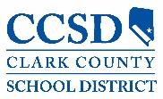

Our mission is to provide the tools for students to be independent and successful, both academically and socially.

5100 West Sahara Avenue
Las Vegas, Nevada 89146

